Chapter 13, Problem 45.

For the circuit shown in Fig. 13.109, find the value of the average power absorbed by the 8-ohm resistor.

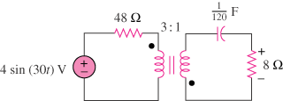

Figure 13.109
For Prob. 13.45.

